SCIE1500 · Analytical Methods for Scientists
Week 1 | Functions & Their Properties — Worksheet
Plastic Pollution: Building a Predictive Model
Group Number: 1 Date: | Members present:

Reference Data

Year | 1950 | 1970 | 1990 | 2010 | 2015
Production (MT) | 2 | 35 | 120 | 270 | 380
Australian data: 19.6 million coastal population · 0.028 kg/person/day waste rate · 2% mismanagement rate

Part A — Function Identification — 20 minutes
Q1 | Plot the global plastic production data (Year vs Production). Which function family best describes the shape — linear, quadratic, or exponential? Justify your choice.
 | 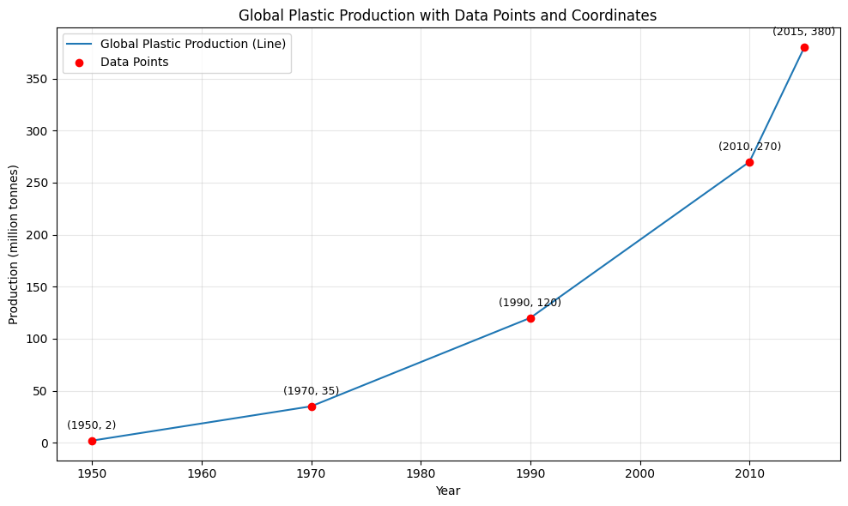
Q2 | Linear model from 1990–2015:  - Calculate the slope (rate of change in million tonnes/year).  - Write the linear function P(t) where t = years since 1990.  - What does the slope mean in real-world terms?
- Slope = (380-120)/(2015-1990)= 10.4 MT
- Y=10.4x+2
- Since 1990 10.4MT of plastic has been produced.
Q3 | Quadratic model P(t) = at² + bt + c through (1990, 120), (2010, 270), (2015, 380):  - Set up the system of three equations (you do not need to solve it fully).  - What would a positive coefficient a indicate about the rate of growth?
a)

(1990, 120) | (2010, 270) | (2015, 380)
P(40)= 120  a(40)^2 + b(40) + 2 =120  a(40)^2 + b(40) =118 | P(60)= 270  a(60)^2 + b(60) + 2 =270  a(60)^2 + b(60) =268 | P(65)= 380  a(65)^2 + b(65) + 2 =380  a(65)^2 + b(65) =378

b)
A positive coefficient would indicate that the sides of the parabola curve up.

Part B — Domain & Range Analysis — 15 minutes
Q4 | For your linear model from Q2:  - State the mathematical domain.  - State a sensible physical domain — and explain why they differ.  - State the range over your physical domain.
(f) Math domain- |R
(g) Domain physical = (0,65)
(h) range = [2,380]

Q5 | The Reisser depth model uses Cᵢ = Cₛ / (1 − e^{−d·wᵦ·A₀⁻¹}) with all parameters > 0:  - What happens to Cᵢ as d → 0 (very shallow sampling)?  - What does Cᵢ approach as d → ∞ (very deep sampling)?
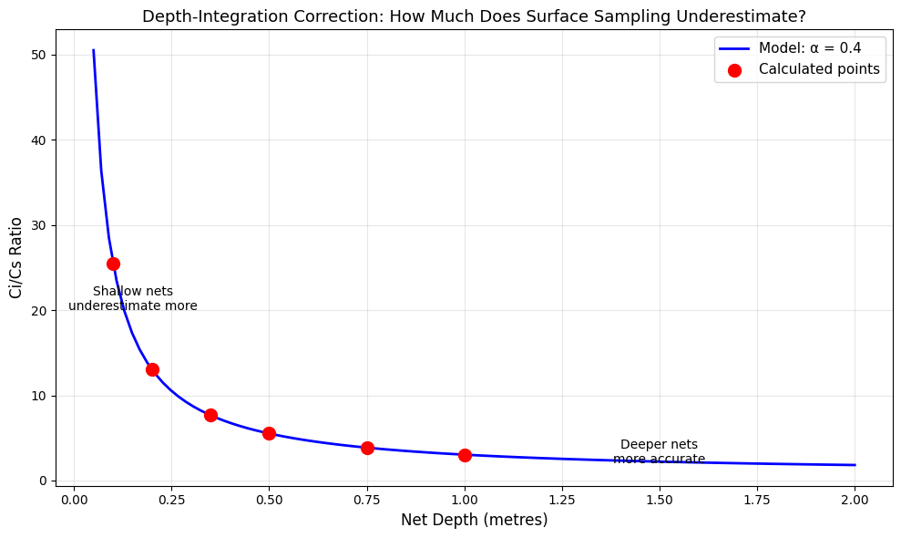
(i) As D approaches 0, Ci increases exponentlially
(j) As D approaches infinity, Ci approaches horizontal asymptote (flat line near zero)

Part C — Australian Policy Application — 20 minutes
Q6 | Calculate Australia's mismanaged plastic waste:  - Daily waste entering waterways (tonnes/day).  - Annual waste (tonnes/year). Show your unit conversion clearly.
k)
Waste entering waterways
19600000 mill x 0.028 kg per person per day
=548800 kg waste x 0.02 (mismanagement rate)
= 10976 kg or 10.9 tonnes per day

l)
Annual waste
19600000 mill x 0.028 kg per person per day
=548800 kg waste per day x 365
=200312000kg/ year
Or 200,312 tonnes per year

Q7 | Write a function W(t) for annual mismanaged waste (tonnes/year), where t = years from 2010, assuming the coastal population grows at 1.5% per year and all other rates remain constant.
Population= 19600000, grows by 1.5%
Population as exponential equation => P(t) = P₀ (1.015)^{t}
= 19,600,000 (1.015)^{t}

Kg of waste per person per year
= 0.028 x 365
=10.22 kg/ per person/ year x 0.02
=0.2044 kg of mismanaged waste per person per year

Total waste
=19600000 x 0.2044
= 4006240 kg per year
Is 4006.24 tonnes

W(t)= 4006.24 (1.015)^{t} tonnes/year, t₀ = 2010

Q8 | The government proposes cutting the mismanagement rate from 2% to 0.5% by 2030. Would this fully offset the population growth effect? Support your answer with calculations and a clear written conclusion.
Total waste per year for 2% mismanagement rate
W₀ = 4006.24 tonnes per year

Population in 2030 => 1.5% growth
t= 2030-2010
= 20

P₂₀₃₀ = 19,600,000 (1.015)²⁰
= 26,398,358
A 34.7% increase in population

Waste in 2030 with old 2% rate
W₂₀₃₀ = 26398358 x 0.2044
= 5,395,824.38 kg
5395.8 tonnes/ 4006.24
=1.347
34.7%

Waste in 2030 with new mismanagement rate (0.5%)

10.22 kg/ per person/ year x 0.005
= 0.0511 kg/ per person/ year

In comparison to 2010 rate
0.0511 / 0.2044
= 25% of old level
Growth rate of total waste mismanaged from 2010 -> 2030 = 34.7%

W (rate) = 0.25 x 1.347
= 0.3367

W₂₀₃₀(reduced rate) = 0.3367 x 4006.24
= 1349 tonnes/ year

By decreasing the rate of mismanagement to 0.5% the yearly amount of waste mismanaged is cut by 25%, from 4006.24 tonnes/year to 1349 tonnes/year. This reduces the amount of waste mismanaged per year to below 2010 levels.

Reflection & AI Usage Declaration (submit with worksheet)
Most challenging aspect of today's work: Understanding the maths

AI tools used (what you asked / how you verified the response): Sciequant AI and the perplexity AI.
The first 6 questions where completed with the use of Sciequant. I used an AI I was more familiar with for the last two. I asked it to show me the steps required to complete questions 7 and 8.

Python plot attached? ☐ Yes ☐ No — reason:

SCIE1500 · Analytical Methods for Scientists
Week 10 | Mock Exam Workshop — Answer Booklet
Hypothesis Testing: Is This Variant More Infectious?
Group Number: Date: | Members present:

Exam Conditions: 40 minutes timed · No assistance within your group · Show all working
Scenario: Among 11 close contacts of a new viral variant, 9 resulted in infections. The original variant had p = 0.50 transmission probability. Does this evidence support a higher transmission rate?
Binomial PMF: P(X = k) = C(n,k) · pᵏ · (1−p)ⁿ⁻ᵏ For n = 11, p = 0.5: C(11,9) = 55 · C(11,10) = 11 · C(11,11) = 1

Part A — Expected Value Warm-up (10 min)
Q1  ~3 min | 1. Calculate E[X] for the distribution: X takes values {1, 2, 3, 4} with probabilities  {0.1, 0.4, 0.3, 0.2}.
Answer space
Q2  ~3 min | 2. Calculate E[Y] for a fair six-sided die. State the formula and show working.
Answer space

Part B — Setting Up the Test (15 min)
Q3  ~5 min | - State H₀ and Hₐ in words.  - Write H₀ and Hₐ using correct statistical notation (p).
Answer space
Q4  ~3 min | 5. Explain why this is a one-tailed (not two-tailed) test.
Answer space
Q5  ~4 min | 6. Write the Binomial PMF fully for this scenario (substitute n, p, state range of k).
Answer space

Part C — Computing the p-Value (10 min)
Q6–7  ~8 min | - Calculate P(X = 9), P(X = 10), P(X = 11) individually. Show each calculation.  - Sum to get the total p-value P(X ≥ 9 | p = 0.50).

Answer space
Q8  ~2 min | 9. At α = 0.05, do you reject H₀? State your decision clearly.
Answer space

Part D — Interpretation (5 min)
Q9  ~2 min | 10. Write a conclusion in plain language suitable for a public health bulletin.
Answer space
Q10  ~3 min | - Define Type I and Type II errors in this specific context.  - Which error is more costly for public health? Justify briefly.
Answer space

Whiteboard Presentation Notes (prepared after group discussion)
Key equation/result to write on whiteboard:

One common error to warn the class about:

One open question or follow-up worth discussing:

SCIE1500 · Analytical Methods for Scientists
Week 11 | Peer Review Exchange — Worksheet
Trigonometric Modelling: Circadian Rhythms
Group Number: Date: | Members present:

Part 1 — Solve This Problem (30 min · 40% of mark)
Scenario: Core body temperature follows T(t) = A·cos(B(t + C)) + D
Data: Minimum 36.2°C at t = 4 h (4:00 AM) · Maximum 37.4°C at t = 16 h (4:00 PM) · Period = 24 hours
Find each parameter:
D | D = (T_max + T_min) / 2 | D =
A | A = (T_max − T_min) / 2 | A =
B | Period = 2π / B → B = 2π / 24 | B =
C | Cosine peaks at t = 16; solve cos(B(16 + C)) = 1 | C =
Complete model T(t) =
Q5 Verify: Calculate T(4) and T(16) and confirm they match the data.

Q6 Body temperature at midnight T(0) =

Q7 Find all times t ∈ [0, 24) when T(t) = 37.0°C. Show algebraic steps.

Part 2 — Create a Problem for Another Group (20 min · 35% of mark)
Choose a real periodic phenomenon. Write a self-contained problem that another group can solve using A·cos(B(t + C)) + D.
Checklist: ☐ Engaging real context ☐ Max/min values given ☐ Period stated or derivable ☐ Timing reference ☐ At least one 'find value at time t' question ☐ At least one 'find when value equals X' question
Phenomenon / context:

Data given to the other group:

Question 1:

Question 2:

Question 3 (optional):

Your solution (on reverse or separate page — do NOT show the other group):

Part 3 — Solve the Problem You Received (25 min · 25% of mark)
Received from Group: Topic / context:
If the problem is ambiguous or under-specified, state your assumption clearly before solving.
Parameter identification (show working):

Answer to Question 1:

Answer to Question 2:

Answer to Question 3 (if provided):

Any ambiguities encountered and assumptions made:

SCIE1500 · Analytical Methods for Scientists
Week 12 | Gallery Walk Capstone — Worksheet
Linear Programming: Sustainable Campus Dining
Group Number: Date: | Members present:
Q1 Define your decision variables clearly (include units):
Q2 Write the objective function:
Q3 Write all constraints as inequalities (one per line, with nutritional data substituted):
Problem Scenario
The UWA Guild Café must design a weekly menu using two protein sources:
x = serves of plant-based protein (tofu/legumes) · y = serves of chicken
Objective: MINIMISE weekly carbon cost Z = 2x + 8y (kg CO₂ equivalent)
Nutritional constraints (per week): Protein ≥ 350 g · Calories ≥ 3,500 kcal · Iron ≥ 25 mg · Carbon ≤ 20 kg CO₂ Non-negativity: x ≥ 0, y ≥ 0
Part A — Problem Formulation (15 min · 8 marks)

Constraint | Inequality | Binding at optimum?
Protein (≥ 350 g) |  | Binding? ☐ Yes ☐ No
Calories (≥ 3,500 kcal) |  | Binding? ☐ Yes ☐ No
Iron (≥ 25 mg) |  | Binding? ☐ Yes ☐ No
Carbon (≤ 20 kg CO₂) |  | Binding? ☐ Yes ☐ No
Non-negativity (×2) |  | Binding? ☐ Yes ☐ No

Part B — Graphical Solution (25 min · 10 marks)
Q4 Graph all constraint boundary lines below.  Label each line · Shade the feasible region · Mark all corner points | Q5 Corner points (solve pairs of equations):
 |  | Corner Point | x | y | Z = 2x + 8y
 |  | A
 |  | B
 |  | C
 |  | D
 |  | E
Q6 Optimal solution:
Minimum carbon cost Z* = kg CO₂
at x* = serves plant, y* = serves chicken

Q7 Verify all constraints are satisfied at the optimum (tick each):

Axes: x = plant-based serves · y  = chicken serves | - Protein ☐ Calories ☐ Iron ☐ Carbon ☐ Non-negativity

Part C — Interpretation & Sensitivity (15 min · 7 marks)
Q8 Write a 3–4 sentence recommendation to the Guild Café manager. Refer to your numerical results.

Q9 Sensitivity: If the carbon constraint tightens to ≤ 15 kg CO₂, find the new optimal solution. Is the menu still practical?

Gallery Walk — Station Preparation (to set up before rotations begin)
Prepare your station display. Write your 3-sentence explanation below (what you will say to each visiting group):

The one constraint that surprised you most — and why:

Questions you are ready to field from visitors:

Questions to ask at other stations (bring these when you visit):

